Introduction
Experiment 1: Constructing a Circuit to Control a Motor Using chip L293D
We have successfully constructed a circuit containing the L293D to control the rotation of a motor (including stopping, rotating, changing speed, and changing the direction of rotation).

Experiment 2: Measuring the Range of Motor Speed Variation with Different PWM Values and Changes in the Resistance of the Potentiometer
We measured the rotational speed under four conditions: PWM full, 3/4, 2/4, and 1/4, and plotted a speed-ohm graph.

Experiment 3: Controlling the Forward and Reverse Rotation of the Motor
We utilized the principle of the H-bridge to control the motor's forward and reverse rotation by adjusting the voltage levels of IN1 and IN2.

Theory and Technical Background
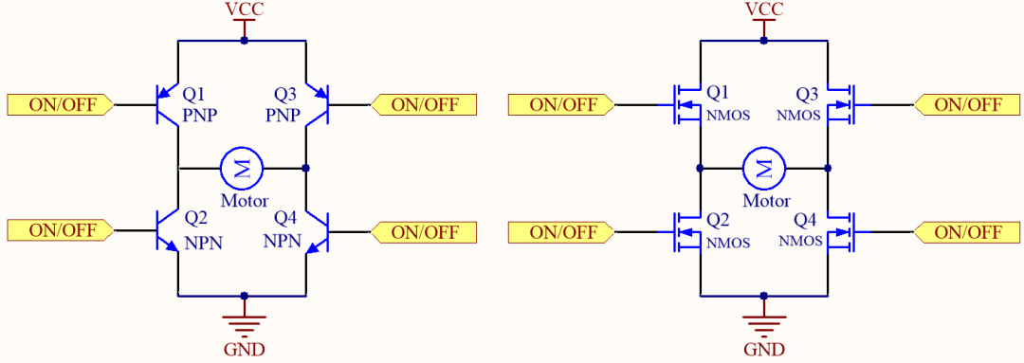
To make the motor operate, a pair of MOSFETs on the diagonal must be turned on. As shown in the figure below, when Q1 and Q4 are turned on (while Q2 and Q3 must remain off), the current flows from the positive terminal of the power supply through Q1 from left to right across the motor, and then returns to the negative terminal of the power supply through Q4. The rotation direction of the motor can be controlled based on the different directions of current flow.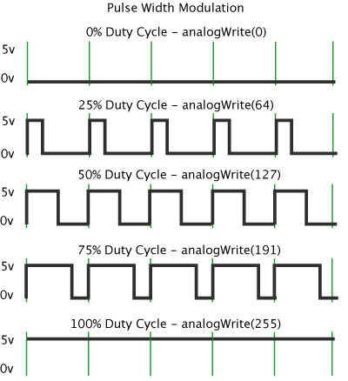
The duty cycle refers to the average rate within a period. The rotation speed of the motor can be controlled based on the ratio of the high-level voltage to the low-level voltage within the period.

Method
abridge | full name
ADC | Analog-to-Digital Conversion
IDE | Integrated Development Environment
DC motor | direct current motor

Key words: L293D, H bridge, indirect measurement

Experiment 1: Constructing a Circuit to Control a Motor Using chip L293D
Utilizing the built-in H-bridge circuit of the L293D chip, precise control of the motor's rotation direction can be achieved by manipulating the voltage state of the Enable Pin 1 and the output pins 1 (out1) and 2 (out2). Specifically, when Enable Pin 1 is at a low voltage level, the motor will not rotate. Conversely, when Enable Pin 1 is at a high voltage level, if output pin 1 (out1) is at a high voltage and output pin 2 (out2) is at a low voltage, the motor will rotate clockwise. On the other hand, if output pin 1 (out1) is at a low voltage and output pin 2 (out2) is at a high voltage, the motor will rotate counterclockwise.
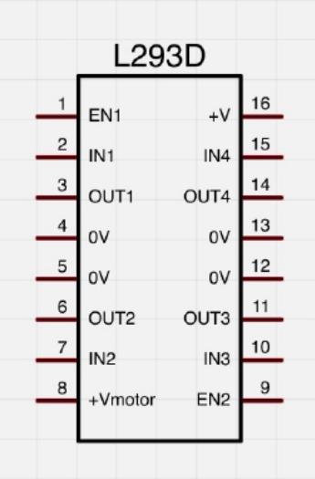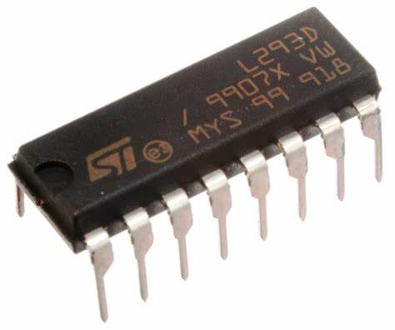
Based on the chip L293D, we built the following circuit:
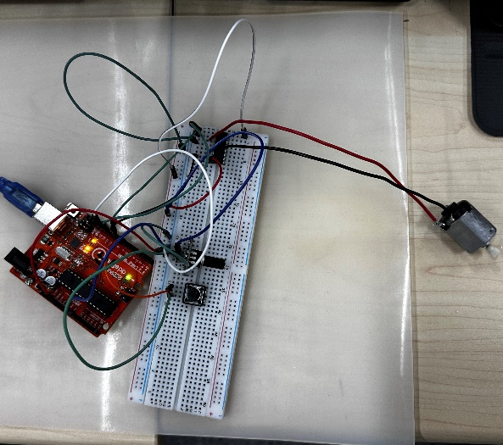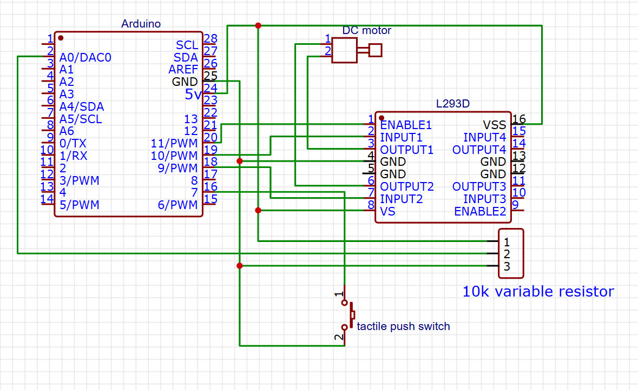

Experiment 2: Measuring the Range of Motor Speed Variation with Different PWM Values and Changes in the Resistance of the Potentiometer
To quantitatively analyze the relationship between the resistance of a variable resistor and the rotation speed of a motor, we employed an indirect measurement method. Specifically, we connected a fixed-value resistor in series with the variable resistor and measured the voltage across this fixed-value resistor. By doing so, we were able to calculate the voltage and current applied across the variable resistor, thereby accurately determining its resistance value. This approach effectively enabled a quantitative analysis of the variable resistor's resistance and provided reliable data support for studying its relationship with the motor's rotation speed.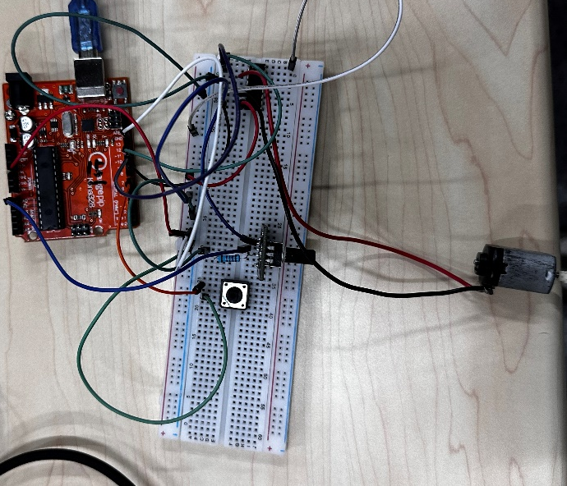 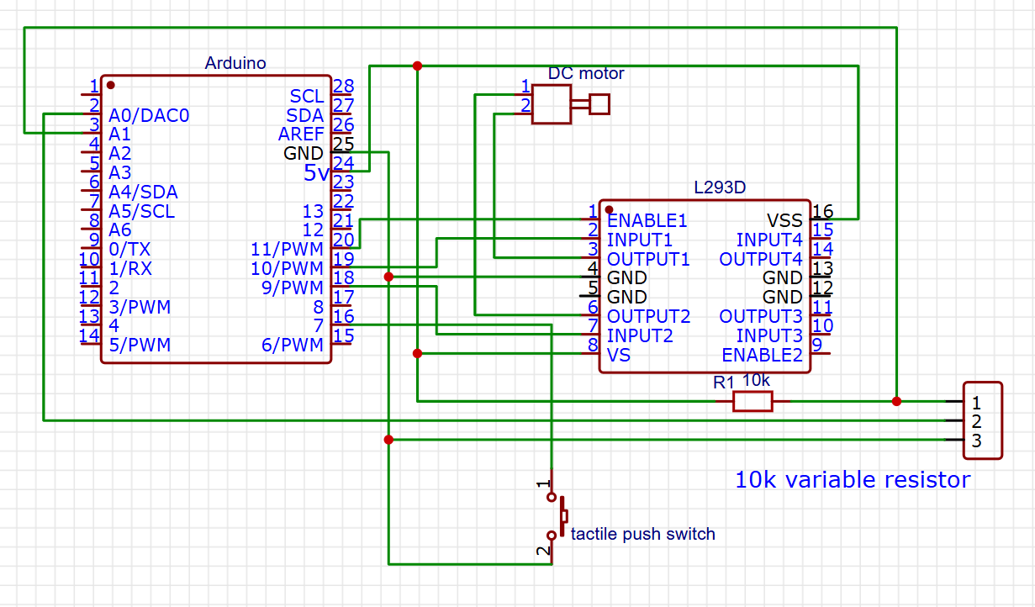

The purpose of this experiment is to obtain the real-time rotational speed of the motor and to calculate the resistance value of the potentiometer through voltage division by connecting a fixed resistor in series. It can be further divided into four sub-experiments with PWM values of full, 3/4, 2/4, and 1/4.Formulas are based on follows：
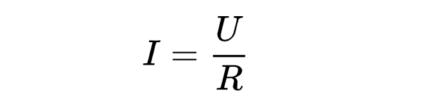
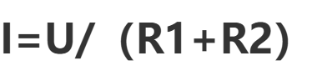

The real-time speed and the corresponding resistance value of the potentiometer are obtained by dividing the value after analog-to-digital conversion (ADC) of the voltage on analog pin A0, acquired through the IDE's Serial Monitor, by 4.

Experiment 3: Controlling the Forward and Reverse Rotation of the Motor
This experiment aims to control the forward and reverse rotation of the motor by using an H-bridge to change the high/low voltage levels of IN1 and IN2. The implementation method is the same as in Experiment 1, so it will not be elaborated further here.
The program is written using Arduino IDE to obtain the voltage values from the analog pins A0 and A1.

Result
Experiment 1:
We have successfully constructed a circuit containing the L293D to control the rotation of a motor (including stopping, rotating, changing speed, and changing the direction of rotation).

Experiment 2:
We obtained the voltage value on analog pin A0 after analog-to-digital conversion (ADC) through the Serial Monitor in the IDE. By dividing this value by 4, we calculated the real-time rotational speed and the corresponding resistance value of the sliding rheostat. The specific details are as follows:
4/4 PWM

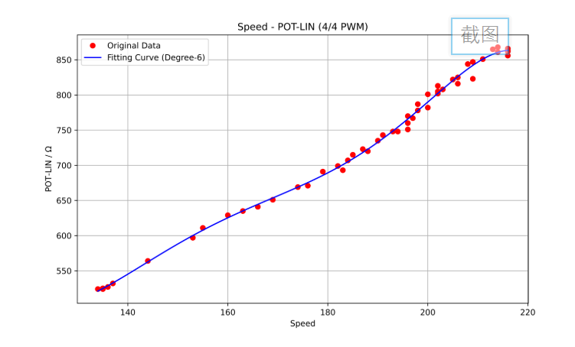
3/4 PWM

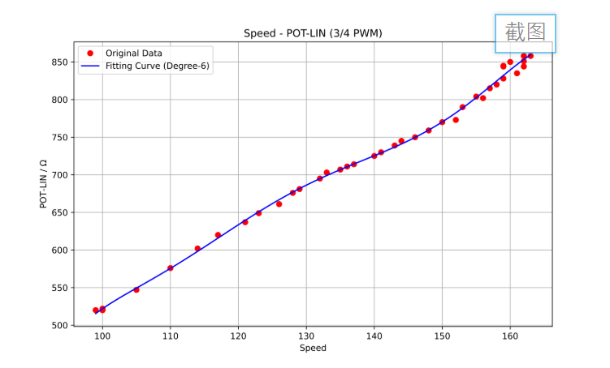
2/4 PWM

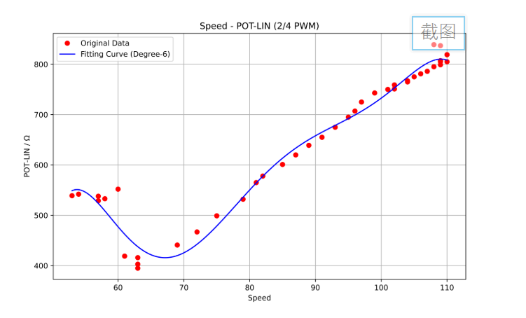
1/4 PWM

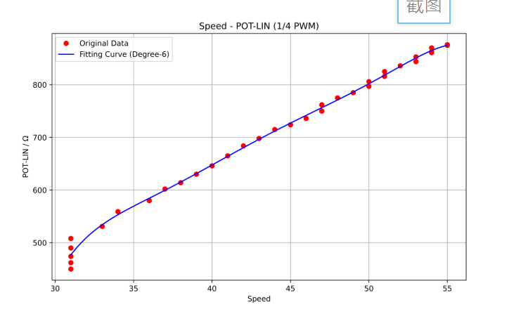
Experiment 3:
The corresponding parameter is obtained through the IDE's Serial Monitor as follows:
Clockwise：
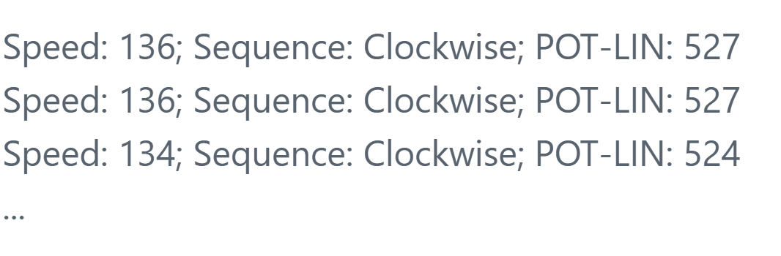
Counter-Clockwise
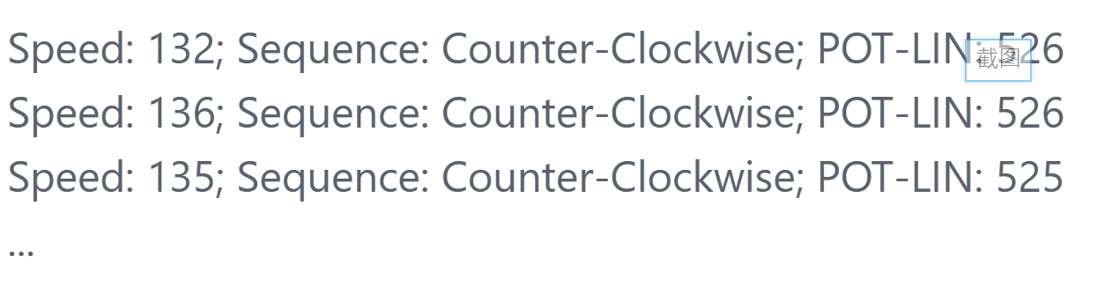

Conclusion
- Conclusion and Summary:
This experiment can be divided into three sub-experiments:
1. Using the L293D Chip to Drive a DC Motor: We successfully utilized the L293D chip to control the rotation of a DC motor, including starting, stopping, and changing the speed and direction of rotation.

2. Measuring Motor Speed Under Different PWM Conditions: We investigated how the motor speed varied with voltage changes under different PWM (Pulse Width Modulation) settings. Since the resistance of the sliding rheostat cannot be measured directly, we connected a 10 kΩ resistor in series to indirectly measure the voltage and thereby calculate the motor speed.

3. Controlling Motor Direction with an H-Bridge: By manipulating the voltage levels at the IN1 and IN2 terminals of the H-bridge, we were able to control the direction of the motor, enabling it to rotate either clockwise or counterclockwise.

Through these experiments, we have gained a thorough understanding of the principles of the H-bridge and the control of DC motors. This knowledge will serve as a solid foundation for our future projects, such as controlling the speed and direction of a small vehicle's wheels.

- Limitations of the experiment:
1. The range of the sliding rheostat used in this experiment is unknown. Moreover, the resistance cannot be manually controlled to change linearly, which may introduce certain experimental errors.

2. The rotor of the motor used in this experiment has some sticking issues, which may lead to deviations when we visually observe and record the motor’s rotation.

